**Assignment 2**

Develop an "Automatic garage door opening system". Use an Ultrasonic sensor to detect if there is a vehicle in front of the garage. if any vehicle is detected open the garage door (rotate the servo motor) for some time and close it.

**Code:**

#include<Servo.h>

int trigpin=7;

int echopin=6;

int ledpin=13;

Servo motor;

void setup()

{

pinMode(trigpin,OUTPUT);

pinMode(echopin,INPUT);

pinMode(ledpin,OUTPUT);

Serial.begin(9600);

motor.attach(5);

}

void loop()

{

digitalWrite(trigpin,HIGH);

delay(1000);

digitalWrite(trigpin,LOW);

int duration = pulseIn(echopin,HIGH);

int distance = (duration*0.034)/2;

Serial.println("the distance is");

Serial.println(distance);

delay(1000);

if ((distance>=50)&&(distance<=200)){

motor.write(180);

Serial.println("Servo is at angle 180");

delay(1000);

digitalWrite(ledpin,HIGH);

delay(1000);

}

else{

motor.write(0);

Serial.println("Servo is at angle 0");

delay(1000);

digitalWrite(ledpin,LOW);

}

}

**Circuit Diagram:**

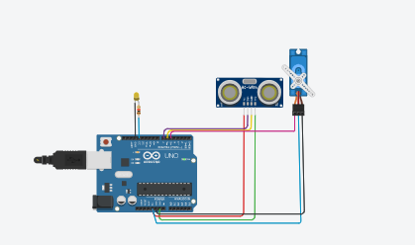

**Output:**

